**Project Design Phase-II**

**Technology Stack (Architecture & Stack)**

**Technical Architecture:**

The Deliverable shall include the architectural diagram as below and the information as per the table1 & table 2

**Order processing during pandemics for online mode.**

**Reference:** <https://developer.ibm.com/patterns/ai-powered-backend-system-for-order-processing-during-pandemics>

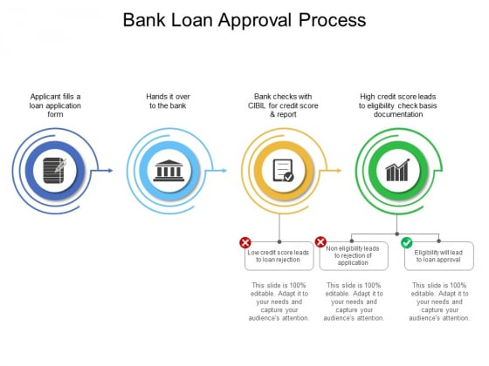

Guidelines:

1. Include all the processes (As an application logic / Technology Block)

2. Provide infrastructural demarcation (Local / Cloud)

3. Indicate external interfaces (third party API’s etc.)

4. Indicate Data Storage components / services

5. Indicate interface to machine learning models (if applicable)

**Table-1 : Components & Technologies:**

|  |  |  |  |
| --- | --- | --- | --- |
| **S.NO** | **Component** | **Description** | **Technology** |
| 1. | User Interface | How user interacts with application e.g. Web  UI, Mobile App, Chatbot etc. | Python with applied Data science |
| 2. | Application Logic-1 | Logic for a process in the application | Python with applied Data science |
| 3. | Application Logic-2 | Logic for a process in the application | Python with applied Data science |
| 4. | Application Logic-3 | Logic for a process in the application | Python with applied Data science |
| 5. | Database | Data Type, Configurations etc. | Python |
| 6. | Cloud Database | Database Service on Cloud | IBM DB2. |
| 7. | File Storage | File storage requirements | IBM Block Storage or Other Storage  Service or Local Filesystem |
| 8. | External API-1 | Purpose of External API used in the application | IBM Bank API, etc. |
| 9. | External API-2 | Purpose of External API used in the application | Aadhar API, etc. |
| 10. | Machine Learning Model | Purpose of Machine Learning Model | Data science |
| 11. | Infrastructure(Server / Cloud) | Application Deployment on Local System / Cloud  Local Server Configuration:  Cloud Server Configuration : | Local, Cloud etc. |

**Table-2: Application Characteristics:**

|  |  |  |  |
| --- | --- | --- | --- |
| **S.No** | **Characteristics** | **Description** | **Technology** |
| 1. | Open-Source Frameworks | List the open-source frameworks used | Technology of Opensource framework |
| 2. | Security Implementations | List all the security / access controls implemented,  use of firewalls etc. | e.g. SHA-256, Encryptions, IAM  Controls, OWASP etc. |
| 3. | Scalable Architecture | Justify the scalability of architecture (3 – tier, Microservices) | Technology used |
| **S.No** | **Characteristics** | **Description** | **Technology** |
| 4. | Availability | Justify the availability of application (e.g. use of  load balancers, distributed servers etc.) | Technology used |
| 5. | Performance | Design consideration for the performance of the  application (number of requests per sec, use of  Cache) etc. | Technology used |

**References:**

**<https://c4model.com/>**

**<https://developer.ibm.com/patterns/online-order-processing-system-during-pandemic/>**

**<https://www.ibm.com/cloud/architecture> <https://aws.amazon.com/architecture>**

**<https://medium.com/the-internal-startup/how-to-draw-useful-technical-architecture-diagrams-2d20c9fda90d>**